**Smart waste management system for metropolitan cities**

Step 1

Problem Solution cards

#problem statement

1.What’s most valuable to the customer?

2.What are we the best at?

3.What are we looking to improve?

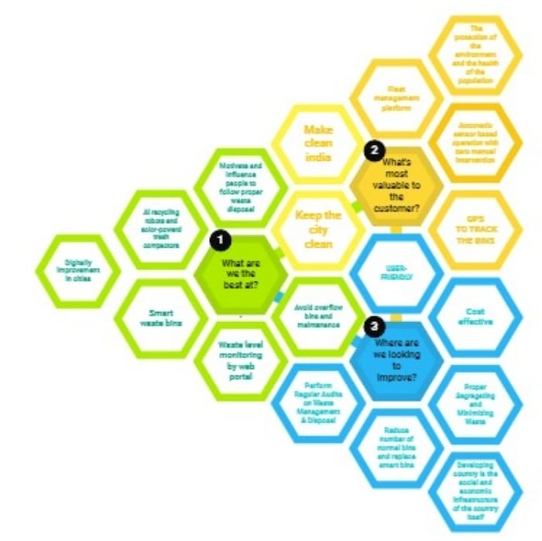

Step 2:

Framing Statements

Smart waste management system framing

The greatest problem regarding waste management in developing countries begins at the very starting point of the process. Due to lack of proper systems for disposal and collections, wastes and garbage's end up in the roads and surrounding. According to a report from Google research, the amount of waste generation in 2010 was around 20,000 tons per day, and it is estimated that by 2025 the amount will be no less than around 47000 tons per day. With the existing methods of collecting and disposal it is near impossible to manage such amount of waste in the future as around 30% of waste end up on the roads and public places due to ineffective disposing and collecting methods. Not only that, there is even no systematic methodology for the collected garbage for treating and recycling thus most of them end up in land filling and river water, making the environment unhealthier.

The prime impediment of implementing smart waste management system based on lot in a developing country is the social and economic infrastructure of the country itself.

The initial stage of this system comprises of proper disposal and collection, which is the biggest challenge. In addition, to motivate and influence people to follow proper waste disposal methods is also important.

Step 3:

Ideas

Problem Solution

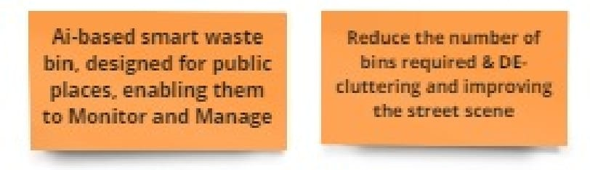

Previously there were numerous initiatives on waste management and educating people to dispose waste properly, and as they failed to achieve significant results, we have figured out the scopes that could be develop. To solve this problem, we have designed a process that ensures proper disposal and efficient waste collection. The procedures we designed involves creative initiative that will inspire people to dump in designated area or bins, and innovative method by using Decreasing Time algorithm or DTA for monitoring garbage generation and collection of the garbage's.